Laboratory practice No. II: Brute Force

Carla Daniela Rendón  Universidad Eafit  Medellín, Colombia  cdrendonb@eafit.edu.co | Full name of second student  Universidad Eafit  Medellín, Colombia  Correointegrante2@eafit.edu.co

3) Practice for final project defense presentation

- backtraking is an algorithm widely used to solve the problem of n-queens, proposed by Edsger Dijkstra in 1972 to illustrate the power of so-called structured programming. The search for brute force should not be confused with backtracking, since this is a method that discards many sets of solutions, without explicitly listing each one of them.

Value of N | Execution Time
4 | 0,1s
5 | 0,1s
6 | 0,1s
7 | 0,1 s
8 | 0,1s
9 | 0,2s
10 | 0,3s
11 | 0,3s
12 | 0,6s
13 | 0,6s
14 | 0,8s
15 | 1s
16 | 1s
17 | 4s
18 | 6s
19 | 7s
20 | 10s
21 | 10s
22 | 15s
23 | 20s
24 | 40s
25 | 70s
26 | 180s
27 | 1000s
28 | 20000s
29 | Se demora mas de 50 min
30 | Se demora mas de 50 min
31 | Se demora mas de 50 min
32 | Se demora mas de 50 min
N | O(n!)

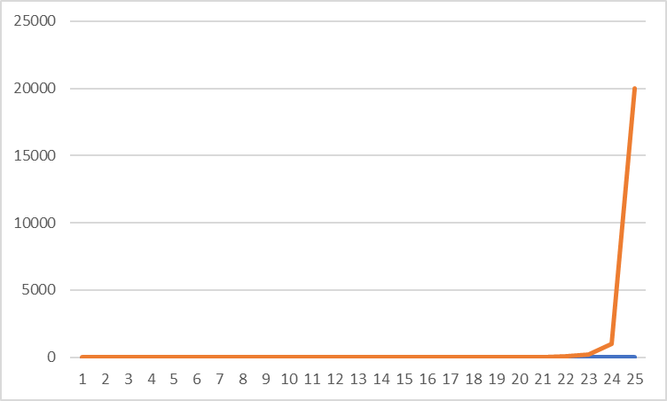

4) Practice for midterms

- a) actual > maximo, b) O(n^2)
- a) arr, k b)O(n^2)
- a) i,n b) O(N-M)
- a) i , b) b

